**#AndroidDevChallenge**

[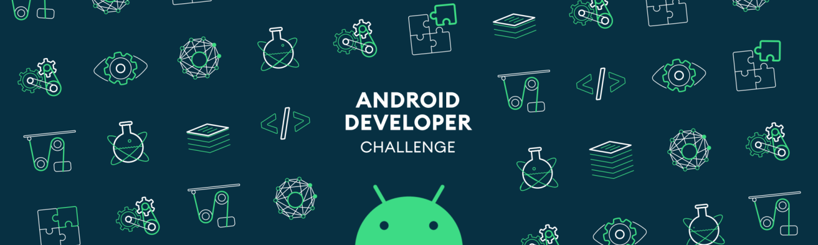](https://github.com/Parag0506/AndroidDevChallenge/blob/master/assets/androidDevChallenge.png)

**Android application for "Smart Food Management Assistant".**

**Tell us what your idea is.  
Describe in 250 words what the feature or service will do and how you’ll use Machine Learning to push the bar:**  
  
**Problem Statement:**

Food is one of primary needs for our life .Consuming healthy food gives us energy for work.

Sometimes it is difficult to take a decision for making food with the available ingredients in kitchen.

**Solution:**

I propose the solution that will be on device ML based Android application which will help the user to make a decision on the basis of the available ingredients in kitchen .It not only help user to but also help to making food by interacting with user and tell the recipe step by step.

**All Functionalities:**

1. It gives suggestion to user what to make in the basis of available ingredients in kitchen with the help of machine learning model which have inputs as food ingredients and the output gives the prediction of list of preparations .
2. It also take care of user health. According to user body(height, weight, any disease user have) it will filter the foods and also calculate the calories, protein, fat etc . This feature can be implemented by using custom Tensorflow model.
3. **Another big functionality** of this app is if the user have excessive food then instead of wasting it they can donate the food to the nearest NGO to distribute the food to the poor people who need it.
4. It can interact with user by voice recognition (This feature helps user to prepare a food item by telling the recipe step by step) and it has also different language preference which need Google Speech API.
5. Image prediction ML model which help user to identify a food item by using device camera.

**Tell us how you plan on bringing it to life.  
Describe where your project is, how you could use Google’s help in the endeavor, and how you plan on using On-Device ML technology to bring the concept to life. The best submissions have a great idea combined with a concrete path of where you plan on going, which should include:**

1. **any potential sample code you’ve already written,**

The project is in initial state, the idea is made. Practical work is not started yet.

1. **a list of the ways you could use Google’s help,**
   1. Assign a Mentor for the project .
   2. Google ML kit access.
   3. Google cloud API(Voice recognisation ).
   4. TF Lite.
   5. A google playstore account for publishing app.
   6. Data set for train the model.
2. **as well as the timeline on how you plan on bringing it to life by May 1, 2020.**

Here’s the toolkit to bring Drivety App (prototype at minimum) idea to fruition.

**Software:**

● IDE Android Studio.

● Java Programming Language.

● Food ingredient, recipe, health diet Datasets.

● TensorFlow (TF) Lite + Converter.

● SpeechRecognizer API.

● Mobile Vision API.

**Timeline:**

**By December 2019:**

Starting the development work.

Project structuring and setup  
Android Application beta model  
Research and Learning

**January 2020:**

Finalising the best possible method for the application  
Creating all the activities required for the stractere.  
Development and UI/UX designs.

**February 2020 :**

Integrating the machine learning models in the app.

**March 2020 :**

Documenting and Training Models with all the data sets.

**April 2020 :**

* Testing and debugging errors.

● Publish final app to Google Play Store.

**Tell us about you.  
A great idea is just one part of the equation; we also want to learn a bit more about you. Share with us some of your other projects so we can get an idea of how we can assist you with your project.**

Hi, My name is **Hiron Saha** , I am a student of 3rd year Computer Science & Engineering .Starting Android Development since 2017 I have made many apps in my college for projects some of links given below:-

>(<https://github.com/hiron1999/Media_player.git>)

>(<https://github.com/hiron1999/Server-connection.git>)

**Know more about me:**

Github:( <https://github.com/hiron1999>)

Linkedin:( <https://www.linkedin.com/in/hiron-saha-b7912b198>)

Gmail:([hironsaha0@gmail.com](mailto:hironsaha0@gmail.com))

**Next steps.**

* Be sure to include this cover letter in your GitHub repository
* Your GitHub repository should be tagged #AndroidDevChallenge
* Don’t forget to include other items in your GitHub repository to help us evaluate your submission; you can include prior projects you've worked on, sample code you've already built for this project, or anything else you think could be helpful in evaluating your concept and your ability to build it
* [**The final step is to fill out this form to officially submit your proposal.**](https://docs.google.com/forms/d/e/1FAIpQLSe43koQL33IzgxXQl29Ex3AhFuqd4hQzxLiXREqwRkDGtx1vA/viewform?usp=sf_link)